

**FPT APTECH COMPUTER EDUCATION**

Do Hoang Giang A04991

Vu Viet Hung A04990

Tong Manh Long A04977

**School Management System**

**User guide**

# Table of content.

1. Config connection
2. Welcome interface
3. Admin login

Admin Control Center

View staff info and edit

Add staff

Delete staff

View batch info

1. Staff login

Staff Control Center

View staff info

Add student

Batch Manager

Search Student

1. Student login

View information and mark

Start the application, the form **Connection** appear:

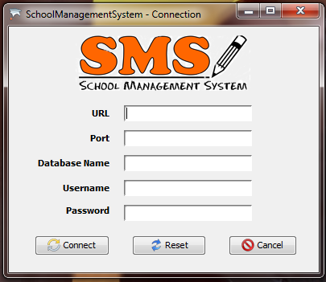

You need enter folow :

* URL : jdbc:sqlserver
* Port : 1433
* Database Name: SchoolManagementSystem
* Username: sa
* Password: 123456

If connection correct. It go to the Welcome form:

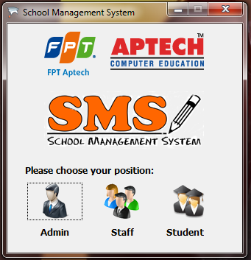

* There are three type of Account:
  + Administrator
  + Staff
  + Student

If you’re **Administrator**, click to Admin icon, the Admin Login is appear:

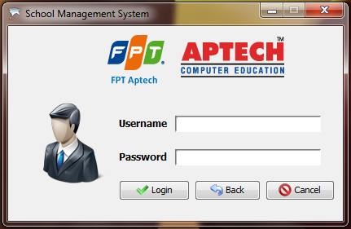

Enter username and password of Administrator,if correct it go to Admin Control Center

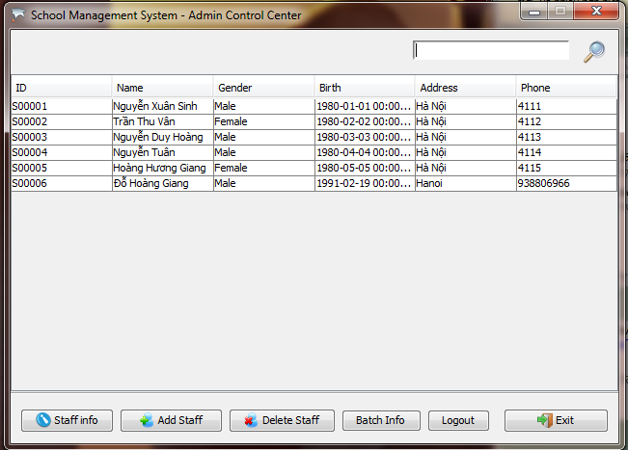

**Staff info** : Select a staff at table and click the button “Staff info” to view all staff information

**Add Staff** : Click to open Add Staff form to add new staff

**Delete Staff** : Select a staff at table and click the button “Delete Staff” to delete staff

**Batch Info** : Click to open batch info

**Logout** : Click to logout Adminstrator account

**Exit**: quit the application

1. Staff info

Select a staff at table and click the button “Staff info” to view all staff information

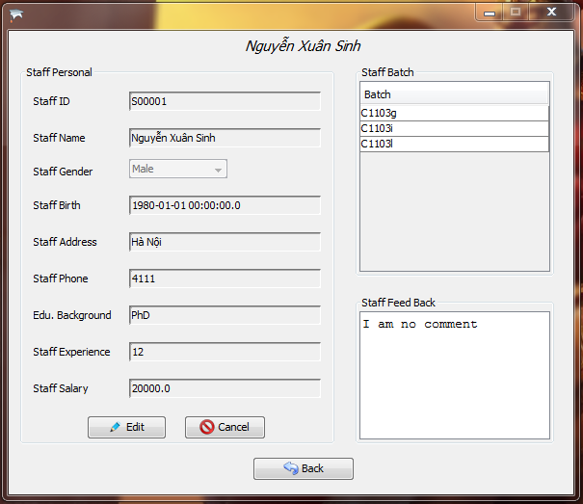

**Edit** : click the butto to edit staff information, after edit click Edit button again to save.

**Cancel**: after edit, if you don’t want save click Cancel button

**Back**: click to back **Admin Control Center** form

1. Add staff

Add a new staff

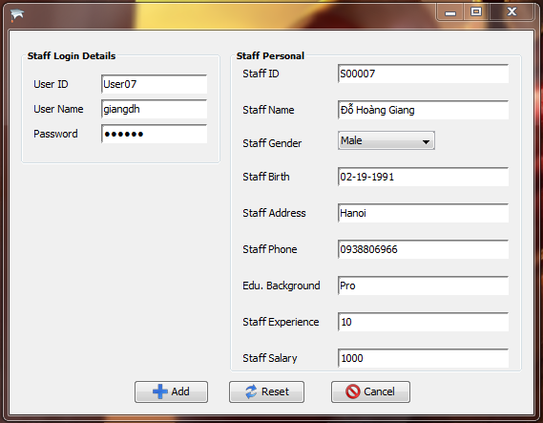

**Add** : after enter full information, click Add button to add new staff

**Reset** : if the information that you’re enter not correct, click Reset button to clear all

**Cancel** : Exit Add Staff form

1. Delete Staff

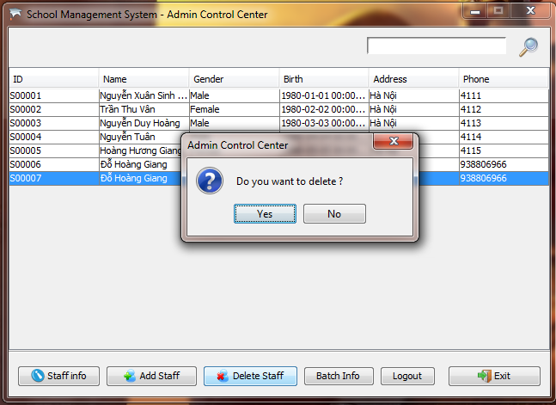

Select staff that you want to delete and click “Delete Staff” button.

1. Batch Info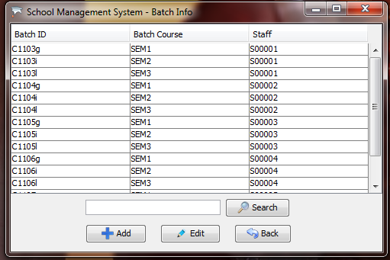

**Add** : click to add a new batch

**Edit** : select a batch at table and click Edit button to edit Batch information

**Search**: Search batch information by BatchID

**Back**: back to Admin Control Center

**Staff Login**

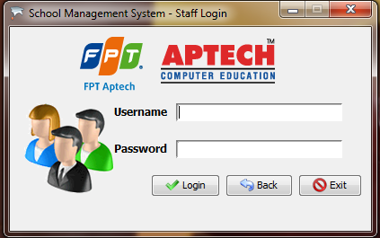

**Staff Control Center**

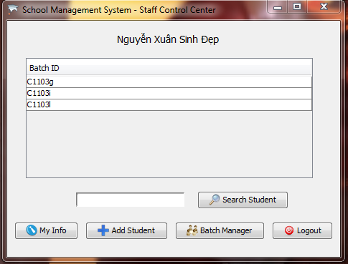

**My Info** : click to view details information

**Add Student** : click to open Add Student form to add a new student

**Batch Manager**: click to open Batch Manager form

**Search Student**: enter Registration No of student and click Search Student button to search student

**Logout**: logout staff account

**My Info form**

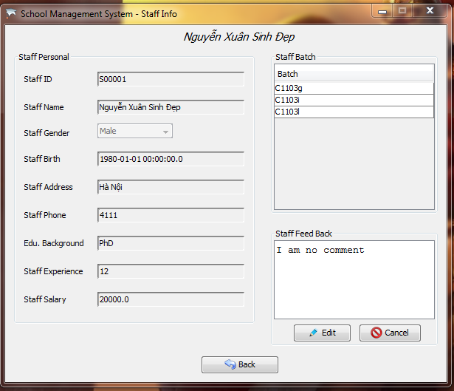

**Edit**: Edit comment

**Cancel**: Cancel edit comment

**Back**: Back to Staff Control Center

**Add Student form**

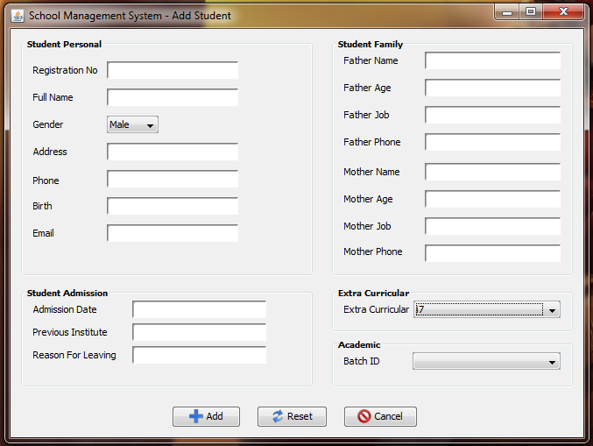

**Add:** after enter full information, click Add button to add a new student

**Reset:** clear all information that you were input

**Cancel**: Close window and back to Staff Control Center

**Batch Manager**

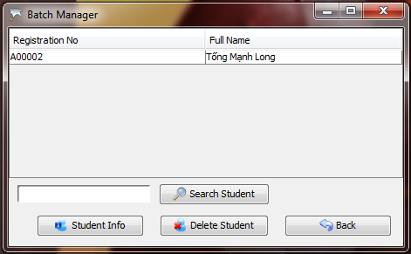

**Student Info**: Select a student at table and click Student Info button to show all information of student

**Delete Student**: Select a student at table and click Delete Student button to delete student

**Search Student**: Enter Registration No of student and click Search Student button to search

**Back**: Back to Staff Control Center form

**Staff Control Center - Student Info**

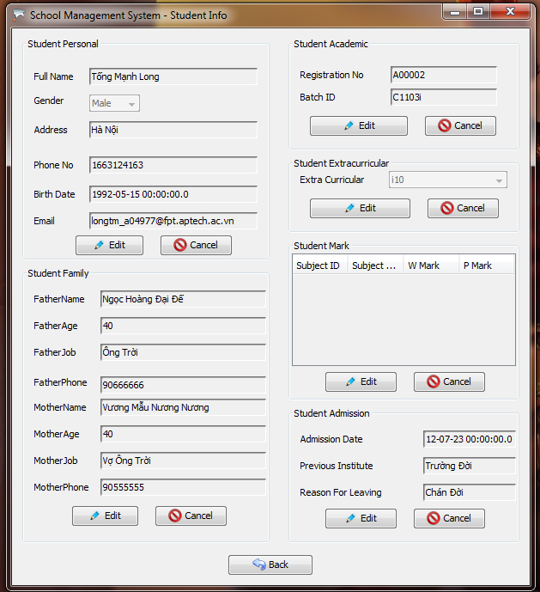

**Staff Control Center – Mark**

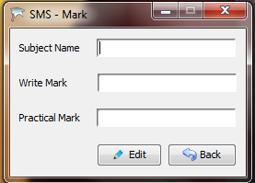

**Edit:** after enter Subject name, write mark, practical mark, click Edit button to add new subject mark

**Back**: Back to Staff Control Center

**Student**

At Welcome form, click to Student icon, Student can see all their information

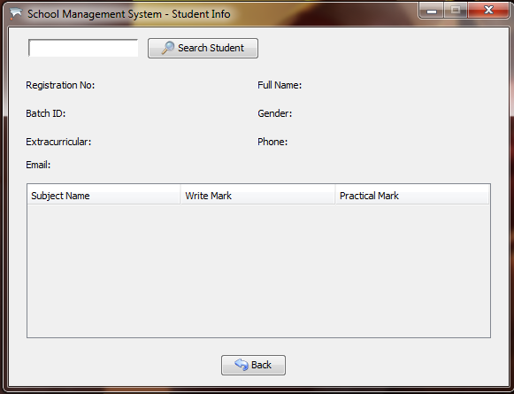

**Search**: after enter Registration No of student at textfield, click Search Student button to search all information of student.

**Back**: Back to Welcome form